
SRS
Software Requirements Specification

Nathalie Crespo
Wyatt Byroade
Philemon Petit-Frere

1. Introduction 4
1.1 Purpose 4
1.2 Scope 5
1.3 Product Overview 6
1.3.1 Product Perspective 6
1.3.2 Product functions 10
1.3.3 User characteristics 12
1.3.4 Limitations 13
1.4 Definition 13
2. References 14
3. Specific Requirements 14
3.1 External Interfaces 17
3.2 Functions 23
3.3 Usability requirements 25
3.4 Performance requirements 25
4 Verification 26
5. Appendices 28
5.1 Assumptions and Dependencies 28
5.2 Acronyms and Abbreviations 28

Revision History
Name | Date | Reason For Changes | Version
DOF_SRS_001 | 4/4/2019 | Start of Document | 1.0.0
DOF_SRS_002 | 4/18/2019 | Addition of mockups | 1.0.1
DOF_SRS_003 | 4/28/2019 | Validation | 1.0.2

1. Introduction
As the barrier to entry for photography has been reduced by technology improving the quality and lowering the cost of photographic equipment, most professional photography companies can expect a steady decline in the average dollar amount spent and the rate of participation at most photo shoots. In order to maintain a sustainable business, a modern school and league photography company must photograph the largest possible number of subjects in the most rapid and efficient way possible, while still maintaining a desirable level of quality in all photos taken, and ensuring that all possible parents have an opportunity to view and easily order the photos being taken.
Currently, acquiring contact information from subjects consists of manually entering handwritten fields from sign-in sheets or order forms. Associating images with subjects has been done by either manually writing down image numbers on order forms or rosters, or by scanning barcodes on cards or labels which were previously distributed to subjects. These processes are time-consuming and error-prone. In order to maximize efficiency, minimize errors and reduce labor costs, the proposed software will streamline the process of receiving contact information from the subject and it will automate the association of images with subjects.

1.1 Purpose
This document lays out a project plan for the development of a new software to which will improve the efficiency of acquiring and transferring data between user inputs and a kiosk system.
The intended readers of this document are current and future developers working on this new project and the sponsors of the project. The plan will include, but is not restricted to, a summary of the software and functionality, the scope of the project from the perspective of the developers, scheduling and delivery estimates, project risks and how those risks will be mitigated, the process by which the project will be developed, and metrics and measurements that will be recorded throughout the project.

In short, the purpose of this SRS document is to provide a detailed overview of our software product, its parameters, and goals. This document describes the project's target audience and its user interface, hardware and software requirements. It defines how our client, team, and audience see the product and its functionality. Nonetheless, it helps any designer and developer to assist in software delivery lifecycle processes.

1.2 Scope
The DOF Technology new proposed software will be used to quickly acquire and manage subject data, and automatically link portraits to each subject as they are taken by the photographers. This will cut down on a great deal of manual copying, renaming and associating images with subjects after the shoot is completed. Another benefit will be the elimination of a complex printing and distribution of barcode and QR codes to subjects before a shooting. The user will enter their identification data and have a photo taken at a kiosk. This photo will be used to build a digital profile for the facial recognition software to analysis As most of the administrative tasks will be automatically completed as photos are taken, additional post-processing and interfacing with other systems may be pre-defined and carried out.

All computers will be networked together using Ethernet (preferred) or Wifi. Support from the developer may include a remote connection session to solve errors that cannot be easily resolved by swapping out software or hardware. Subject data will be encrypted and transmitted to the computers at the photography stations, as well as a backup NAS (network-attached storage) on the local network and cloud storage if Internet connectivity is available.

1.3 Product Overview

1.3.1 Product Perspective
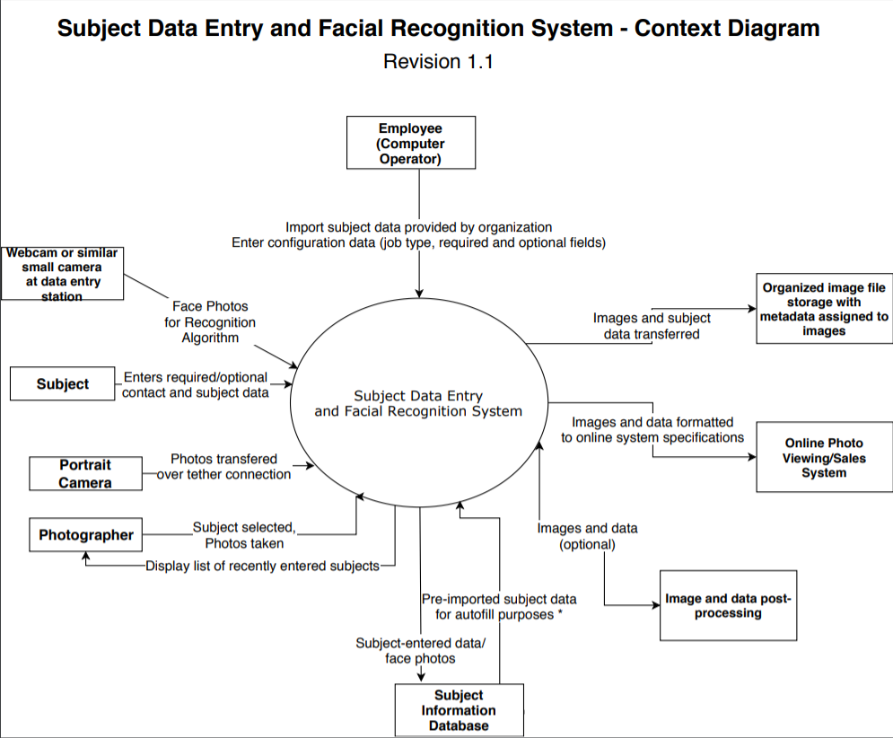
The proposed software will serve as a replacement for the old system.

b) User interfaces:
- The user interface for the software shall be compatible with any OS.
- The user will able to enter their data at the provided text fields on the kiosk screen.
- When the user is done entering data, the kiosk will prompt the user to look at the camera to take a photo.
- When the photographer takes a photo of a subject, the tethered computer will display the matched subject resulting from the algorithm execution.
c) Hardware interfaces:
- The Kiosk, the NAS, and photographer tethered computer will be connected on the same network.
- All devices will have wifi and/or Ethernet capabilities with GB/s connection speed. Kiosk computer will use integrated or external USB connected camera.
- Photographer tethered system will have a digital SLR camera hooked up with USB (2.0, 3.0 or Thunderbolt).

d) Software interfaces:
- File sharing between sign-in kiosk, photographer tethered system and NAS will be carried out via SMB (server message block) protocol.
- Local and network database queries will utilize the SQL syntax.
- As database records are updated on local computers, those updates will be replicated using the SQL Server replication feature of Microsoft SQL Server 2017 (or newer) or Row Based Replication (RBR) feature of MySQL Server.
- Images captured on sign-in kiosk computers will be replicated using RSync.

e) Communications interfaces:
- All local traffic and internet traffic will use TCP/IP
- All internet traffic shall be secured via VPN or TLS connection to cloud server.

f) Memory requirements:
- All components of this software will occupy less than 512MB of memory, which will not be a constraint on even low-end modern systems.

g) Operations;
- Technical Employee Operations
- Employee imports data of the subjects, provided by the school, league or other organization, into the system before the event.
- Employee determines what data should be entered by the subject, including mandatory and optional fields.
- Employee defines how data will be updated and how images will be stored, copied and associated with subjects.

- Subject Operations:
- Subject enters required and options data into fields as they sign-in.
- Certain triggers will induce the subject to look at the screen, at which point low-resolution images will be captured and used by the AI facial recognition algorithms to build a profile for identification.

- Photographer Operations:
- Photographer will begin photographing a subject and watch the monitor as the system automatically identifies the subject.
- If the system is unable to identify the subject, or the system identifies the wrong subject, the photographer may override the selected subject and move any previous photographs to the correct subject association.

h) Site adaptation requirements.
- All modules of the software should be set to photo shoot mode and all have the same job name, file storage directories and databases enabled.

1.3.2 Product functions
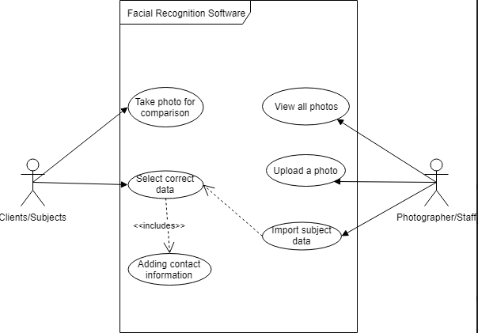
The software will make the process in which acquiring and managing data of the subjects, or customers, is made more efficient. The software when correctly functional will automatically link portraits, or photographs of the subject, to each subject as they are taken by the photographers.
The shoot duration time will be cut shorter, where manually copying renaming and associating pictures was done before.
FE-1: The software will allow an employee to import subject records from various formats (see requirements) into the active database for an upcoming job.
FE-2: The software will allow an employee to specify which fields are required and which are optional upon sign-in of photography subjects.
FE-3: The software will display a set of fields to entering subjects, prompting them to sign in by entering their names and other required or optional information.
FE-4: The software will use a live-search feature as the subject begins entering their first name, last name or unique ID, to display a list of matching subjects, allowing them to click their names and pre-populate fields for information that was already provided by the organization.
FE-5: The software will take two face shots of the subject as they click certain elements on screen, indicating that the subject is most likely looking straight at the screen.
FE-6: When the user has entered all required information, the system will prompt them to continue to the photography stations.
FE-7: The software will update a local database with the newly entered subject information, and then replicate that data across the network.
FE-8: The software will replicate the facial images of the subject across the network to the photography stations.
FE-9: The component of the software running on the photographer tether system will monitor a hot folder for any new images being transferred from the camera.
FE-10: When new images are placed in the hot folder, the software will run a facial recognition algorithm, which calculates features and relative location of certain points of interest (POI) on the face(s) of any subjects in the photo.
FE-11: The software will compare the points of interest with those generated from the photos captured at sign-in kiosks to determine the identity of the subject just photographed.
FE-12: The software will assign the matched images to the subject’s record in the database and add metadata to the JPEG and RAW images with subject identification.
FE-13: If the software fails to match (with at least 90% certainty) a subject or subjects in a photo to signed-in subjects, an error will be displayed, and the photographer will be prompted to manually select or override the subject selection, using a list of recently signed-in subjects.

1.3.3 User characteristics
- Technical Employee (may be the photographer or other employee) - Employees imports initial data, determines how images will be copied, renamed and sent to other systems, and how data will be updated in databases. He/She will need high level of technical expertise in database management.
- Photographer - Photographers will confirm with a subject that the system has automatically determined the correct subject, may change the selected active subject, or drag previous images from incorrect subject to the correct subject in the event of a malfunction. Photographers will need some technical knowledge to able correct and monitor the system.
- Subject - The subjects are primarily the customers. They will interface with the kiosk by entering their data, and the kiosk will take a photograph of them. This can be done by anyone without much computer knowledge, as they will only need a mouse and keyboard. The user interface is currently in English, but other languages can be implemented if needed.

1.3.4 Limitations
- The identification images captured at the kiosk should be less than 600 KB in size.
- For the Cloud Storage backup to run efficiently the upload speed needs to above 2Mb/s.
- The rate at which subjects can sign in at a single kiosk is limited to approximately 1 per minute. Multiple kiosks likely required for medium to large photo shoots.
- The primary mode of functioning involving the subjects entering their data will only be viable for subjects with that capability (not viable for elementary or preschool-age children).

1.4 Definition

Photographer Tether System | A computer that will be connected (tethered) to an SLR camera that will be used to capture portraits and identify subjects
QR | (Quick Response code) A matrix barcode that contains a piece of information
NAS | (Network-attached storage) Computer data storage server connected to a computer network
Subject | The user who will interact with the kiosk system, and who will be photographed
Tether(ed) | The connection via USB cable from a digital camera to a computer for the purpose of transferring images as they are captured
TLS | (Transport layer security) is a protocol that provides communication security between client/server apps on the internet.

2. References
- ISO/IEC/IEEE International Standard 29148 (2011 Version): https://www.iso.org/standard/45171.html
- EU General Data Protection Regulation (GDPR): https://gdpr.eu/tag/gdpr/
- Depth of Field Technologies System Requirements Specification

3. Specific Requirements
Employee Role:
3.1.1 The system shall allow an employee to create an organization designation that will allow customization of required and optional subject data fields based on the needs of that client organization.
3.1.2 The system shall allow an employee to create a photo shoot job designation that shall allow customization of required and optional subject data fields based on the needs of that job.
3.1.3 The system shall group all data by photo shoot and by client organization to allow for export or processing of multiple photo shoots for a client organization or of one photo shoot at a time.
3.1.4 The system shall allow subject data for a photo shoot to be imported prior to the photo shoot from files of the following formats: SQL, SQLite3, NoSQL (MongoDB, Neo4j), XLS (Excel Spreadsheet), XLSX (Excel Spreadsheet XML-based), Access database, CSV (comma-separated values), tab-delimited text file or PDF.
3.1.5 The system shall allow selection of relevant fields from data source to be mapped to subject data fields within the destination system.
3.1.6 The system shall require that the employee assigns one subject data field to be a unique identifier, either provided by source data, or assigned and automatically generated by the system.
3.1.7 The system shall allow subject data to be exported to the following formats: SQL, SQLite3, NoSQL (MongoDB, Neo4j), XLS (Excel Spreadsheet), XLSX (Excel Spreadsheet XML-based), CSV (comma-separated values), PDF or file structure consisting of a hierarchy of groupings, the bottom level of which is a directory for each subject containing the photos taken, as well as metadata in text files and attached to the images.
3.1.8 The system shall allow custom graphical templates to be created with transparent PNG images and XML or JSON files describing positioning of subject images, textual information, barcodes and QR codes.

Customer Role:
3.1.9 The system shall allow custom graphical templates to be created with transparent PNG images and XML or JSON files describing positioning of subject images, textual information, barcodes and QR codes.
3.1.10 The system shall provide subjects with a way to sign in and provide textual information when arriving at the photo shoot through the use of a computer sign-in kiosk.
3.1.11 The system shall use a live-search algorithm to display a list of matching subjects as the subject types in his/her last name, first name, unique ID, jersey number or other custom data field (as determined by system administrator for a specific photo shoot or client organization).
3.1.12 When a user clicks on his/her name as provided by the live-search algorithm, all data fields that were provided by the organization shall pre-fill with that subject’s data.
3.1.13 When a user clicks on his/her name as provided by the live-search algorithm, a photo of the subject shall be captured by built-in webcam or other camera attached to the sign-in kiosk (assuming that the action of clicking the button shall draw the subject’s eyes to the screen, allowing for a photo that can be used with facial recognition algorithm.)
3.1.14 The system shall prevent the subject from being able to complete sign-in process until data has been provided for all required fields.
3.1.15 The system shall capture a photo of the subject when the “Sign in” button is clicked (assuming that the action of clicking the button will draw the subject’s eyes to the screen, allowing for a photo that can be used with facial recognition algorithm.)
3.1.16 The system shall provide validation on email fields to ensure that the data entered fits the following regular expression (.*@.*\..*) before sign-in is allowed.
3.1.17 The system shall provide validation on telephone number fields to ensure that the data entered fits the following regular expression ([0-9\(\-\.]{10-15}) before sign-in is allowed.
Photographer Role:
3.1.18 The system shall monitor all photos captured from photographers’ tethered systems.
3.1.19 When an image is captured, the system shall run facial recognition algorithm to create a mathematical formula of the subject’s face, and embed the resultant formula as a metadata tag embedded in the image file.
3.1.20 When an image is captured and facial recognition formula is saved, the system shall first compare that formula with the formula saved in memory from the previous image.
3.1.20.1 If the formulas match, no further comparison is done and subject information persists.
3.1.20.2 If the formulas do not match, the system shall begin comparing the formula with that of each subject captured at the sign-in kiosks, beginning with the earliest subjects to sign in that have not been photographed, then comparing with all other subjects.
3.1.21 When the facial recognition algorithm matches a captured image with a new subject, the system prominently displays the name of the subject to allow the photographer and subject to confirm a correct identification.
3.1.22 As each image is captured by the photographer, the subject shall be checked and the name of the subject continuously displayed.
3.1.23 The photographer shall be able to override the identification made by the facial recognition algorithm by manually selecting a subject and assigning one or more images to that subject.
3.1.24 In the event of a photographer override, the system shall log the event and store all related images and facial recognition formulas for later review.
3.1.25 The photographer should be able to temporarily disable facial recognition and subject assignment of images to allow for test shots to be taken.
3.1.26 The photographer should be allowed to remove subject assignment from one or more images in the event of an image being captured that should not be made available to the subject.

3.1 External Interfaces
3.1.1 | Name of item: Previously entered subject data: ID (if applicable), last name, first name, grade (if applicable), various other possible fields as provided from organization and as configured by staff  Description of purpose: These items are used to identify and sort subjects and used when exporting future products and data sets  Source and destination: Imported manually or from preexisting data source (XLS, CSV, SQL, DBA); inserted into subject database  Timing: Imported prior to photo shoot  Relationships to other inputs/outputs: Will be merged with other captured subject data; used to look up subjects to streamline sign-in data entry process  Screen formats/organization: terminal interface/not relevant  Windows formats/organization: terminal interface/not relevant  Data formats: ID: alphanumeric, last name and first name: alphanumeric with punctuation, grade: alphanumeric  Command formats: importdata -source=[filename.ext] -map={[field1_dest_name]:[field1_src_name], [field2_dest_name]:[field2_src_name], ....}  End messages: “data imported - [num] rows inserted into database”;  “Data import failure - field mismatch” “data import failure - invalid characters”

3.1.2 | Name of item: Contact data entered by subject during sign-in process including email address(es), cell phone number(s), various other possible fields as configured by staff  Description of purpose: These items are used to contact subjects, send proofs; also used when exporting future products and data sets  Source and destination: Entered by subject during sign-in process; used to update subject records in database  Timing: Entered upon arrival at photo shoot, prior to being photographed  Relationships to other inputs/outputs: Will be merged with other captured subject data; used to contact subject with proofing/purchase options  Screen formats/organization: (concept only - to be designed)  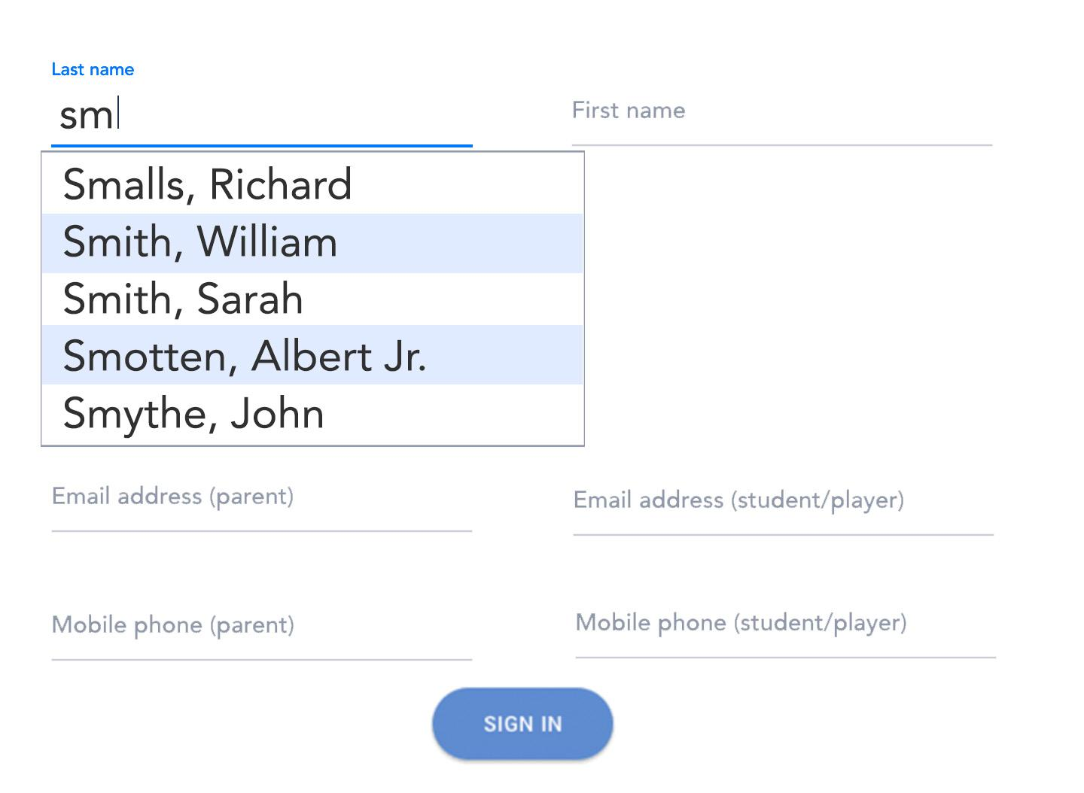  Data formats: Last name and first name: alphanumeric with punctuation, Email: alphanumeric with characters [-_.@], Mobile phone: numeric with characters [-.]  Command formats: not applicable  End messages: “Sign-in Successful - Proceed to Photography Station XX”

3.1.3 | Name of item: Capture of identification images at sign-in kiosk  Description of purpose: Images of subjects’ faces will be taken at sign-in and compared against portraits to automatically identify subjects  Source and destination: Taken by webcam or other attached camera, stored locally and transferred over the network to NAS and photographer tethered stations.  Timing: When the subject clicks the sign-in button (implying that the subject is looking at the screen) an image will be captured. Also, may optionally prompt user to look at camera.  Relationships to other inputs/outputs: Images will be tagged with subject unique ID and transferred simultaneously with database replication queries.  Screen formats/organization: See external interface 3.1.2 above  Data formats: JPG with EXIF metadata  Command formats: scp [local image path]/[image name] [remote system]/[remote path]  Endmessages: exit code 0 of scp process

3.1.4 | Name of item: Capture of portraits at photography station  Description of purpose: Portraits of subjects captured for the purposes of sale, yearbook and other products.  Source and destination: Taken by professional SLR camera over USB attachment, stored locally and transferred over the network to NAS.  Timing: As the image is captured by the camera, the file is automatically transferred over USB and placed in hot-folder.  Relationships to other inputs/outputs: When image appears in hot-folder, the facial recognition algorithm will automatically be executed.  Screen formats/organization: not applicable  Data formats: JPG with EXIF metadata  Endmessages: Files (JPG/NEF) transferred successfully

3.1.5 | Name of item: Subject identification and display at photography station  Description of purpose: Visually indicate the detection of images in the hot-folder and the results of the facial recognition matching algorithm  Source and destination: Results of internal processes and files; displayed on screen  Timing: Output will update immediately as images are detected in hot-folder and again when the result of the facial recognition algorithm is returned.  Relationships to other inputs/outputs: Screen will display images as they are detected in hot-folder. Screen will display output of facial recognition algorithm.  Screen formats/organization: (concept only - to be designed)  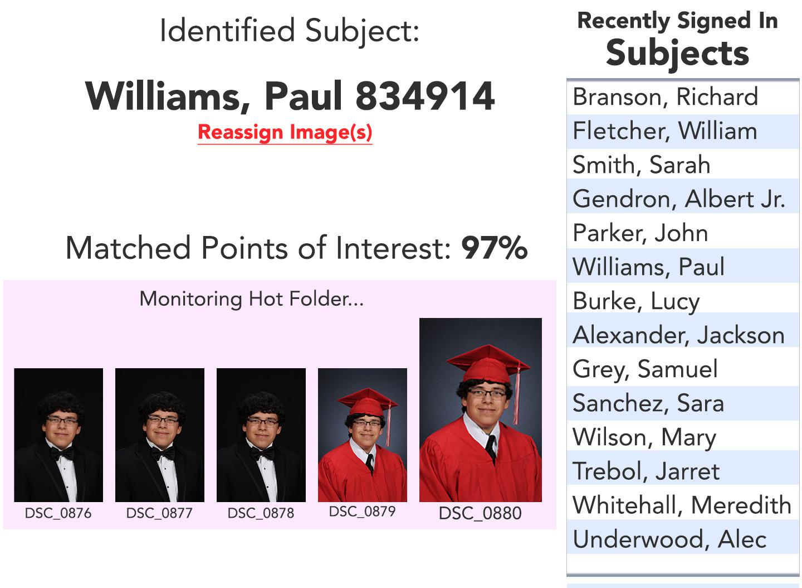  Data formats: JPEG, JSON (result of facial recognition matching algorithm)  Command formats: cycleDisplayImages(Image newImage); displayMatchResult(FacRecMatch currentMatch)

3.1.6 | Name of item: Subject identification override or manual override at photography station  Description of purpose: Allow photographer to override erroneous matches and manually select subjects if a match is not possible (for example a subject with special needs who was assisted in signing in and identification images could not be captured).  Source and destination: Photographer will initiate the process of overriding or manually selecting subject. Result will associate subject identification with image by adding meta tag as well as inserting image name and subject unique ID in database.  Timing: Input can be entered prior to or following the capture of image(s).  Relationships to other inputs/outputs: A manual override of the facial recognition algorithm will cause further images captured of the same subject to be run in algorithm, but not to automatically trust result.  Screen formats/organization: (concept only - to be designed)  Command formats: overrideImageIdentification(String subjectUniqueID); identifySubject(String subjectUniqueID);

3.1.7 | Name of item: Output of identified portraits and identification images to file system  Description of purpose: Update meta tags of locally stored images, and transfer updated images to NAS  Source and destination: Image hot folder, identification images cache -> NAS  Timing: Files transferred immediately after identification is made and meta tags are updated  Screen formats/organization: not applicable  Data formats: JPEG with EXIF metadata  Command formats: scp [local image path]/[image name] [remote system]/[remote path]  Endmessages: exit code 0 from scp process

3.1.7 | Name of item: Output of subject data and image list to database  Description of purpose: Insert each image as a row in database table, update number of images captured to subject record  Source and destination: Result of facial recognition matching algorithm or manual assignment of images to subject -> SQL (or other database architecture)  Timing: Queries executed after series of images of a certain subject ends and the next subject is matched.  Relationships to other inputs/outputs: list of captured images to be included in insert query  Screen formats/organization: not applicable  Data formats: SQL query  Command formats: insert into ImageSubject (subjectID, imageFileName, imageCapturedTimeStamp) VALUES (‘[subjectID]’, ‘[imageFileName]’, ‘[imageCapturedTimeStamp]’), (‘[subjectID]’, ‘[imageFileName]’, ‘[imageCapturedTimeStamp]’), (...), (...)...;  Endmessages: SQL Response ([numberOfCapturedImages] rows affected)

3.2 Functions
3.2.1 Process data fields as entered by subject during sign-in process.
- Validity checks on inputs: Email address: Alphanumeric with punctuation ( . _ @) with required regex match: [a-z0-9\._]+@[a-z0-9\._]+\.[a-z0-9\._]+ Phone number: numeric with punctuation ( ( ) . - )
- Exact sequence of operations: Display live-search algorithm results as characters are entered in last name or first name fields. Auto-fill fields with subject data when a subject name is clicked. When sign-in button is clicked, validate fields and update subject database with newly-entered data.
- Responses to abnormal situations: 1) If invalid data is entered, reject sign-in and highlight field that needs to be revised. 2) If subject is entered that does not exist in previously imported data, create new subject record. 3) If database insert/update fails, display error message asking subject to find a staff member.
- Relationships of inputs to outputs: Inputs: Subject last name, first name, uniqueID, [grade], [jersey number], email address(es), telephone number(s) Outputs: Subject update query, subject insert query

3.2.2 Capture identification image(s) during sign-in process
- Validity checks on inputs: Image is properly formatted and complete JPEG image; Face in image is within range of angles for extraction of landmarks/features used in facial recognition algorithm.
- Exact sequence of operations: When sign-in button is clicked (indicating subject is looking straight at screen), capture a photo of the subject’s face, validate the image, extract landmarks/features, transfer images to photographer stations.
- Responses to abnormal situations: 1) If image does not validate, attempt to capture another photo. After three failed attempts, sign in subject without identifying image. 2) If camera and computer lose communication, display error requesting the subject ask for help from staff and cease taking input. 3) If network communication fails, display error requesting the subject ask for help from staff and cease taking input.
- Relationships of inputs to outputs: Inputs: Subject unique ID, captured identification images Outputs: Identification images with metadata attached

3.2.3 Run facial recognition matching algorithm on portraits captured at photography stations
- Validity checks on inputs: Image is properly formatted and complete JPEG image; Face in image is within range of angles for extraction of landmarks/features used in facial recognition algorithm. Facial recognition algorithm produces match from signed-in subjects.
- Exact sequence of operations: 1) Hot folder is monitored by the software. 2) When a new image is detected in hot folder, execute facial recognition algorithm. 3) Display name and unique ID of matched subject on screen. 4) Add name and unique ID of subject to image metadata. 5) When a new subject is matched, update database.
- Responses to abnormal situations: 1) If facial recognition algorithm does not find a match, display error message prompting photographer to manually select subject. 2) If facial recognition algorithm fails to execute or consistently fails to match subjects, display specific error to photographer. 3) If photographer overrides match, use the assigned image as the new identifying image for the subject. 4) If network communication fails, display specific error to photographer.
- Relationships of inputs to outputs: Inputs: Captured portrait, folder containing multiple subject identification images, result of manual selection of subject by photographer Outputs: Captured portrait with subject name and unique ID added to metadata. Database update/insert queries to Subject and ImageSubject

3.3 Usability requirements
3.3.1 Focus should automatically be placed in a relevant field (first name or last name) after one subject signs in.
3.3.2 System should use live-search algorithm to display matching subjects as a subject begins to type first name, last name, unique ID or jersey number.
3.3.3 System should allow multiple images to be selected by a photographer and re-assigned to a different subject.
3.3.4 If a subject enters his/her name and other information and no pre-imported record exists, the system should create a new subject and assign a new unique ID, while logging an event that an unmatched subject was signed in.

3.4 Performance requirements
3.4.1 The system should insert or update the record into the database on the server in less than .2 seconds.
3.4.2 The system should save identification images to local disc storage in less than .2 seconds.
3.4.3 The identification images captured at the kiosk should be less than 600KB in size.
3.4.4 The system should use a network with minimum speed of 1Gb/s, preferably using wired Ethernet; some systems may run on 802.11ac with MIMO (multiple input multiple output) multiplexing.
3.4.5 The system should be able to incrementally replicate the subject database and identification images from the server to all networked systems (sign-in kiosks, photographers’ tethered systems) in less than 4 seconds.
3.4.6 The system should replicate the subject database and identification images from the server to all networked systems every time a subject signs in or once per minute while multiple subjects are signing in per minute.
3.4.7 Facial recognition algorithms shall be executed locally on each photographer system using locally stored identification images (replicated from server).
3.4.8 When transfer bandwidth to/from the server is below a certain configurable threshold, subject images from photographers’ tethered systems shall be backed up to server and/or standalone NAS system.
3.4.9 When an internet connection is present, the database shall be replicated to a cloud backup server.
3.4.10 When an internet connection is present and tests indicate an upload speed of more than 2Mb/s, all subject images shall be uploaded to cloud backup server.

4 Verification
Demonstration is a requirement that the system can demonstrate without external test equipment.
Test is a requirement that requires some external piece of test equipment (e.g. logic analyzer, and/or volt meter).
Analyze is a requirement that is met indirectly through a logical conclusion or mathematical analysis of a result. For example, Algorithms for congestion: the designer may need to show that the requirement is met through the analysis of count and occupancy calculations in software or firmware.
Inspection is the nondestructive examination of a product or system using one or more of the five senses (visual, auditory, olfactory, tactile, taste). It may include simple physical manipulation and measurements.

  Requirement ID | Verification Method
  3.1.1 | D
  3.1.2 | D
  3.1.3 | D
  3.1.4 | D
  3.1.5 | D
  3.1.6 | D
  3.1.7 | D
  3.1.8 | D
  3.1.9 | D
  3.1.10 | D
  3.1.11 | T
  3.1.12 | D
  3.1.13 | A
  3.1.14 | D
  3.1.15 | D
  3.1.16 | D
  3.1.17 | D
  3.1.18 | A
  3.1.19 | T
  3.1.20 | A
  3.1.20.1 | A
  3.1.20.2 | A
  3.1.21 | D
  3.1.22 | D
  3.1.23 | D
  3.1.24 | A
  3.1.25 | D
  3.1.26 | D
  3.1.27 | A
  3.2.1 | D
  3.2.2 | A
  3.2.3 | A
  3.2.4 | D
  3.3.1 | A
  3.3.2 | D
  3.3.3 | D
  3.3.4 | D
  3.4.1 | A
  3.4.2 | D
  3.4.3 | D
  3.4.4 | T
  3.4.5 | A
  3.4.6 | A
  3.4.8 | D
  3.4.9 | D
  3.4.10 | A

5. Appendices

5.1 Assumptions and Dependencies
- It is assumed that on-site computers and software are performing normally. If problems arise, a technical support expert should be able to address and handle the problem.
- Subjects will be able to input their data without many errors.
- Photographers will be able to test the facial recognition with their own test data without fail.
- The computers will have the right Operating System to run the software.
- The kiosks are performing at normal level, any issues with this will cause delays.

5.2 Acronyms and Abbreviations
- QR Code: Quick Response Code
- NAS: Network-Attached Storage
- OS: Operating System
- GBL: Gigabyte
- USB: Universal Serial Bus
- SLR: Single-lens Reflex Camera
- SMB: Server Message Block
- SQL: Structured Query Language
- RBR: Row Based Replication
- TCP/IP: Transmission Control Protocol/Internet Protocol
- VPN: Virtual Private Network
- TLS: Transport Layer Security
- MB: Megabyte
- AI: Artificial Intelligence
- KB: Kilobyte
- XLS: Excel Spreadsheet
- XLSX: Excel Spreadsheet XML-based
- CSV: Comma-Separated Values)
- PDF: Portable Document Format
- XML: Extensible Markup Language
- JSON: JavaScript Object Notation
- MIMO: Multiple Input Multiple Output

